ve

**Manufacturer User Manual v 1.0**

* **Central Equipment Identity Register Manufacturere Portal**

Document Change History

|  |  |  |  |
| --- | --- | --- | --- |
| Version | Change Type | Description | Date |
| Draft |  | Submitted for internal review | March 2020 |

Contents

Document Change History i

Contents ii

Figures iii

1 Overview 1

1.1 Scope 1

1.2 Acronyms & Abbreviations 1

1.3 Conventions 1

2 Manufacturer Operations 2

2.1 Application Overview 2

2.2 Logging into the Application 2

2.3 Application User Interface 8

2.3.1 Dashboard 11

2.4 Stock Management 14

2.5 Edit Stock 19

2.6 Filter Stock 20

2.7 Export Stock 21

2.8 Grievance Management 22

2.9 Filter Grievances 25

2.10 Export Grievances 27

Figures

Figure 1: CEIR Home Page 2

Figure 2: Manufacturer Registration 3

Figure 3: Verify OTP 4

Figure 4: Enter OTP 5

Figure 5: Login 6

Figure 6: Home Page 7

Figure 7: Forgot Password 7

Figure 8: Set New Password 8

Figure 9: Home Page 8

Figure 10: Edit Information 9

Figure 11: Change Password 10

Figure 12: Manage Account 11

Figure 13: Home Page 11

Figure 14: Stock Management 12

Figure 15: Grievance Management 13

Figure 16: Home Page 13

Figure 17: Home Page 15

Figure 18: Stock Management 15

Figure 19: Upload Stock 15

Figure 20: Stock Management 17

Figure 21: Stock Management 19

Figure 22: Edit Stock 19

Figure 23: Stock Management 20

Figure 24: Stock Management 20

Figure 25: Stock Management 21

Figure 26: Open or Save Exported Stock File 21

Figure 27: Exported Stock 21

Figure 28: Home Page 22

Figure 29: Grievance Management 23

Figure 30: Report Grievance 23

Figure 31: Grievance Management 24

Figure 32: Filter Grievances 26

Figure 33: Filtered Grievances 26

Figure 34: Grievance Management 27

Figure 35: Open or Save Exported Grievance File 27

Figure 36: Exported Grievances 27

# Overview

## Scope

The objective of this manual is to help Manufacturers use the CEIR (Central Equipment Identity Register) application to upload stocks that is to be sold in the Cambodian market and report grievances.

## Acronyms & Abbreviations

| **Acronym** | **Full Forms** |
| --- | --- |
| CEIR | Central Equipment Identity Register |
|  |  |
| IMEI | International Mobile Equipment Identity |
|  |  |
| PDA | Personal Digital Assistant |

## Conventions

| **Information** | **Convention** |
| --- | --- |
| UI elements  (such as names of windows, buttons, and fields) | Bold |
| References  (such as names of files, sections, paths, and  parameters) | *Italics* |
| **\*** | Indicates a mandatory field or column |

# Manufacturer Operations

## Application Overview

The CEIR (Central Equipment Identity Register) Manufacturer Portal application is used to upload SIM-based devices that are to be sold in Cambodia.

Manufacturers perform the following tasks:

* Upload stock
* Report grievances

## Logging into the Application

Before login, the Manufacturer must register in the application.

To register:

1. Enter the CEIR Home Portal URL in the browser address bar. This opens the CEIR Home Portal page.

Figure 1: CEIR Home Page

1. Select **Manufacturer** from the **Registration** list.

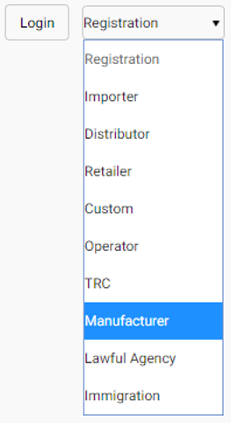

The **Manufacturer Registration** page appears. The Manufacturer needs to fill in the following information.

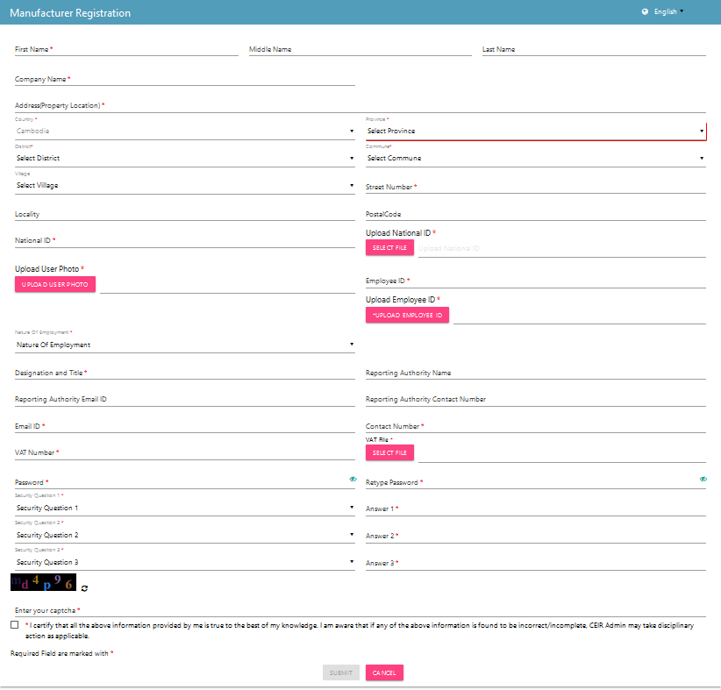

Figure 2: Manufacturer Registration

1. **\*First Name**: Enter the first name.
2. **Middle Name**: Enter the middle name (if any).
3. **Last Name**: Enter the last name.
4. **\*Company Name**: Name of the company
5. **\*Address(Property Location)**: Enter the Manufacturer’s address:
   1. **\***Country
   2. **\***Province
   3. **\***District
   4. **\***Commune
   5. Village
   6. **\***Street Number
   7. Postal Code
6. **\*National ID:** Enter the national ID of the agency personnel.
7. **\*Upload National ID**: Upload the image of the original national ID of the personnel. This can be a pdf or image (.jpeg) of size not more than 2 MB.
8. **\*Upload User Photo**: Upload the photograph of the personnel. The photograph can be a pdf or image (.jpeg) of size not more than 2 MB.
9. **\*Employee ID**: Enter the employee ID.
10. **\*Upload Employee ID**: Upload the image of the ID card. The photograph can be a pdf or image (.jpeg) of size not more than 2 MB.
11. **\*Nature of Employment**: Select the type of employment of the personnel:
    1. Permanent
    2. Temporary
    3. Contract
12. **\*Designation and Title**: Enter the designation of the agency personnel.
13. **Reporting Authority Name**: Enter the name of the officer to whom the personnel reports to.
14. **Reporting Authority Email ID**: Enter the mail ID of the officer to whom the personnel reports to.
15. **Reporting Authority Contact Number**: Enter the contact number of the officer to whom the personnel reports to.
16. **\*Email ID**: Enter the mail ID of the personnel. This mail ID would be used for communication
17. **\*Contact Number**: Enter the mobile number of the personnel. The agency would receive notifications at this mobile number.
18. **\*VAT Number:** Enter the VAT number.
19. **\*VAT File**: Click **Select File** to upload the VAT file.
20. **\*Password**: Enter a login password. This is the password that would be used to log into the CEIR Manufacturer Portal application.
21. **\*Retype Password**: Re-enter the password for confirmation.
22. **\***Select three security questions and enter an answer for each question. This is required by the system when the Manufacturer forgets the password. In such a situation, the system requires identification to authenticate the Manufacturer. These security questions are used for authentication of the Manufacturer.
23. **\***Enter the captcha shown on the page. This is required to prove that the Manufacturer is not a robot.
24. **\***Select the declaration check box.
25. Click **SUBMIT**.

An OTP is sent to the Manufacturer’s mail ID and contact number.

Figure 3: Verify OTP

The Manufacturer is prompted to enter both the OTPs in the page for verification.

Figure 4: Enter OTP

Enter the two OTPs and click **Done**.

If the two OTPs match, the following message appears. If the OTPs do not match, click **Resend OTP**. The two OTPs are resent, one to the contact number and the other to the mail account.

After the OTPs are verified successfully, the registration request is sent to the CEIR Admin. The approval turnaround time is 2-3 days. After approval from the CEIR Admin, a mail containing the Manufacturer’s registration ID is sent to the Manufacturer’s mail account. This registration ID is a unique automatically generated ID. This ID is the login username for access to the CEIR Manufacturer Portal application.

To start using the application, log into the application.

To login:

1. Open the browser and enter the CEIR Manufacturer Portal URL in the address bar. The login screen appears.

Figure 5: Login

On the top right corner of the login screen is the **Language** option. The application supports two languages: **English** and **Khmer**. On selecting a given language, all the field and column labels in the application appear in the selected language. All user inputs are, however, in English.

1. Next, enter the assigned login username and password.

Username is the registration ID that is sent on mail to the Manufacturer after successful registration in the system. The registration ID is a unique ID that is automatically generated by the system. The login password is the password that the Manufacturer enters in the registration page. Refer to during *Figure 2: Manufacturer Registration*.

1. Enter the captcha.
2. Click **LOGIN**.

If the login and password are incorrect or the captcha is not correct, an error message appears, and you are prompted to re-enter the login details.

On entering correct information, the application Home page appears.

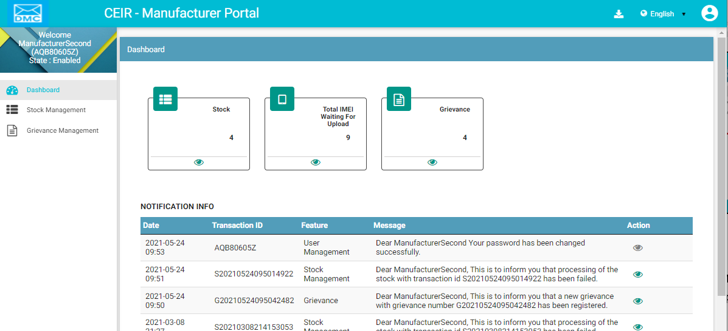

Figure 6: Home Page

If the Manufacturer forgets the assigned password, click the **Forgot Password** link on the **Login** page. The **Forgot Password** page appears.

Figure 7: Forgot Password

1. Enter the login username.
2. Select a security question from the list. Select any one of the security questions that were selected during registration.
3. Enter the answer to the selected security question. This should match the answer given at the time of registration.
4. Click **SUBMIT**.

The **Set New Password** page appears.

Figure 8: Set New Password

1. Enter a new password. Click  to see the password characters being entered. Click on it again to hide the password characters. This works like a toggle key.
2. Re-enter the password.
3. Click **Save**.

## Application User Interface

On logging into the application successfully, the CEIR Manufacturer Portal Home page appears.



Figure 9: Home Page

The Home page has all the feature menus on the left panel.

The center of the page is the Dashboard.

The top right corner of the screen displays the following menu options:

* **Download**: Click to download this user manual.
* **English**: Select **English** or **Khmer**. All the field and column labels appear in the selected language. User inputs are, however, in English.

* **Home**: Click on it to go to the **DMC Home Portal** page.
* A close up of a logo

  Description automatically generated(**User profile**): Click on it to see the following menu:

*  (**Edit Info**): Click on it to modify the registered information. The **Edit Information** page opens.

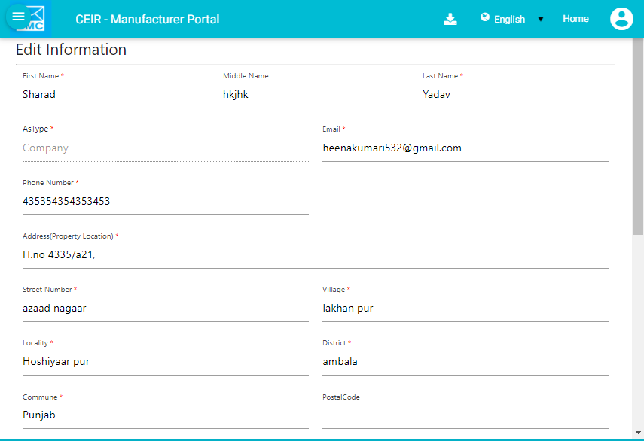

Figure 10: Edit Information

1. Make the required changes.
2. Click **Submit** to save the changes.

*  (**Change Password**): Click on it change the login password.

Figure 11: Change Password

1. **Old Password**: Enter the existing password. Click  to see the password characters being entered. Click on it again to hide the password characters. This works like a toggle key.
2. **New Password**: Enter a new password.
3. **Confirm Password**: Re-enter the new password to confirm the password.
4. Click **SUBMIT**.

*  (**Enable/Disable Account**): Manufacturers can deactivate their account or disable/enable their account.
  + Deactivating an account means deleting the Manufacturer’s account. Once the Manufacturer’s account is deleted, the Manufacturer can raise a grievance to reactivate it when required. The grievance is sent to the CEIR Admin who reactivates the account. After reactivation, the Manufacturer can use the same login username and password to log into the application.
  + When the account is disabled, Manufacturers can only view information and not add or modify information in the application. After the account is disabled, the Manufacturer can enable it using the same menu.

Figure 12: Manage Account

1. Select **Deactivate** or **Disable**.
2. Click **SUBMIT**.

### Dashboard

The Dashboard provides a quick display and access to the following information:

* Stock
* Grievances



Figure 13: Home Page

**Stock**

The stock box displays the total number of stock entries in progress.

Click  (**View)** to access the **Stock Management** dashboard. Refer to *Stock Management* for more information.

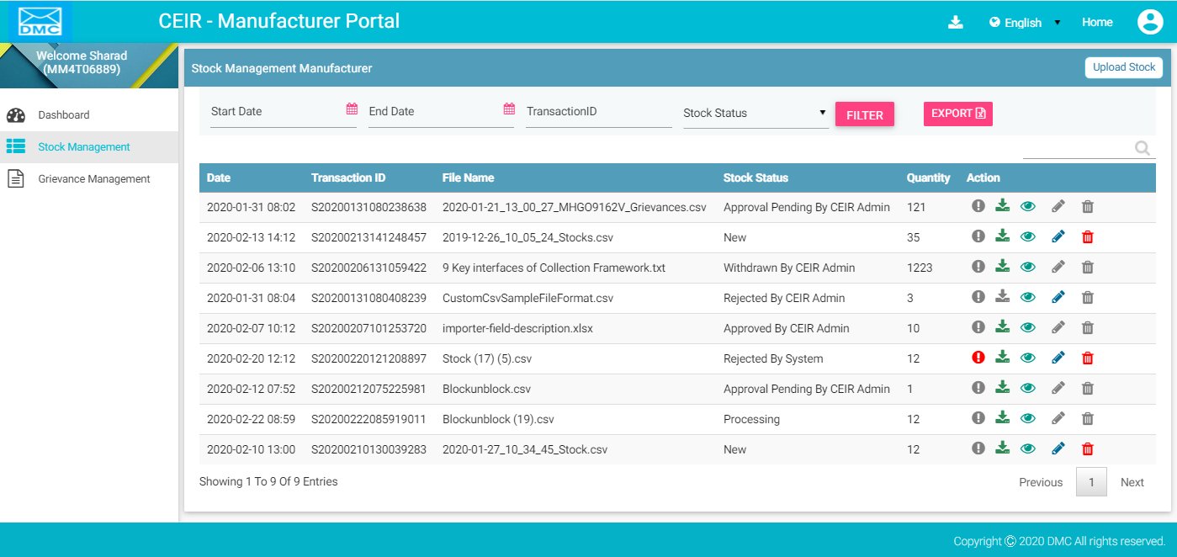

Figure 14: Stock Management

**Total Devices Waiting for Upload**

The box displays the total number of devices (IMEIs in stock) pending for upload.

Click  (**View)** to access the **Stock Management** dashboard. Refer to *Stock Management* for more information.

**Grievances**

The box displays the total number of grievances that are open.

Click  **(View)** to access the **Grievance Management** dashboard. Refer to *Grievance Management* for more information.

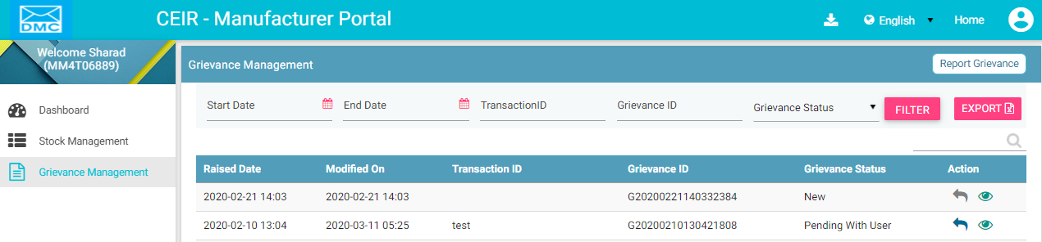

Figure 15: Grievance Management

**Notification Information**

This section displays the ten most recent notifications.

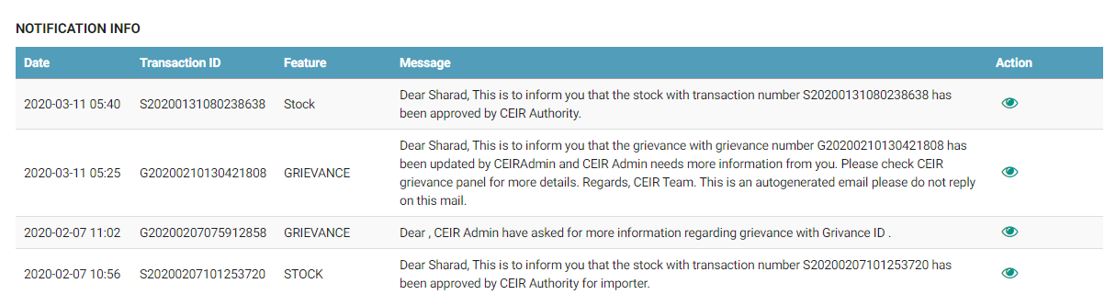

Figure 16: Home Page

Notifications are of two types.

1. Notifications that provide only information. For example, a notification informing the Manufacturer about the account status is an information only notification because it requires no action. The **View** icon () is disabled in such notifications.



1. Notifications that require some action by the Manufacturer. For example, a notification about the Stock upload approval or rejection by the CEIR Admin requires the Manufacturer to take some action such as fix the errors in the stock upload. The **View** icon () is enabled in such notifications. Click  (**View)** to access the relevant page of the notification.



The notification panel has the following columns:

* **Date**: Date of sending the notification
* **Transaction ID**: Transaction ID of the stock or grievance request for which the notification is sent. If the notification is related to the Manufacturer account, the login username is shown instead of any transaction ID.
* **Feature**: This is the name of the feature for which the notification is sent. For example, if the notification is concerning a stock transaction, the feature name **Stock Management** is shown. The feature name is the one shown in the left panel of the Home page.
* **Message**: This is the message of the notification. An example is shown below.



* **Action**: This shows the **View** icon. It is activated  if the Manufacturer can click on it else it is disabled .





## Stock Management

After the Manufacturer produce or assemble SIM based devices, and are ready to be sold in the Cambodian market, then the manufacturer should upload the stock in the CEIR system. To make stock available for sale, stock is uploaded to the system.

To upload stock:

1. Select **Stock Management** in the left panel.



Figure 17: Home Page

1. On selecting the Stock Management option, the **Stock Management** page appears.

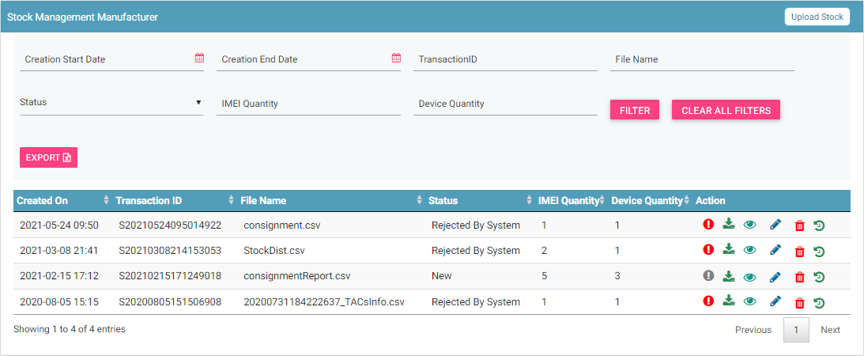

Figure 18: Stock Management

1. Click **Upload Stock**.

The **Upload Stock** page appears.

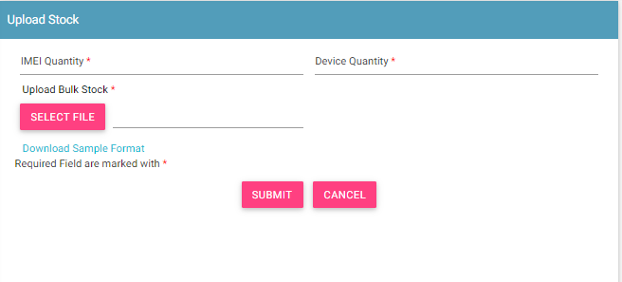

Figure 19: Upload Stock

1. Enter the following information:
   1. **\*IMEI Quantity**: Enter the total quantity of IMEIs.
   2. **\*Device Quantity**: Enter the total number of devices in the bulk file.
   3. **\*Upload Bulk Stock**: Enter the IMEI details in a file. This is a **.csv** file with defined column names. You need to enter device information in this file. First, download the file format, if required.
   4. Click **Download Sample** **Format**.

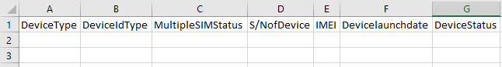

The file has the following columns:

* + **\*Device type**: The device can be a handheld phone, mobile phone, feature phone, smart phone, Vehicle, Portable (include PDA), Module, Dongle, WLAN router, modem, connected computer, tablet, e- Book.
  + **\*Device ID type**: Type can be IMEI (International Mobile Equipment Identity)
  + **\*Multiple SIM Status**: Number of multiple SIMs the device supports (1/2/3/4).
  + **\*S/N of** **Device**: Device serial number
  + **\*IMEI**: Value of IMEI
  + **Device launch** **date**: Launch date or manufacture date of the device (in the format, DDMMYYYY).
  + **Device status**: Whether the device is new or used (New/Used)
  1. Enter the required information in each column for each device.

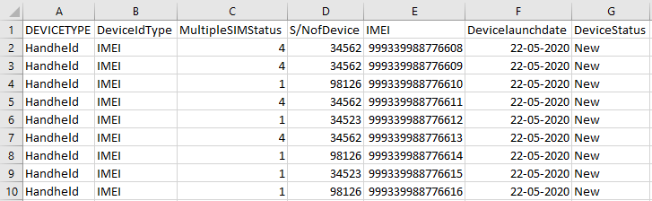

* 1. After you enter the device details, save the file.
  2. Click **SELECT FILE** to upload the file with all the details.

1. Click **SUBMIT**. A unique transaction ID is assigned to the uploaded stock.

The uploaded stock appears on top of the **Stock Management** page.

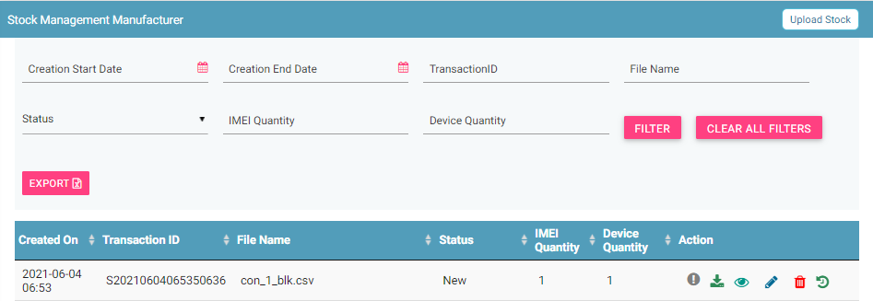

Figure 20: Stock Management

For each stock uploaded, the following columns are seen on the **Stock Management** page.

| **Column** | **Description** |
| --- | --- |
| Date | Date of uploading the stock in the system. |
| Transaction ID | This is an automatically generated ID that helps in identifying and tracking stock. |
| File Name | Name of the stock file. |
| Stock Status | The uploaded stock goes through different status modes.   * New: When the stock is uploaded, its status is **New**. * Processing: The stock is processed and validated. The status changes to **Processing**. * Rejected by System If the stock does not have valid information, an error file is generated. The Manufacturer can view the file and fix the errors in the stock. * Approval Pending by CEIR Admin: The uploaded stock is available for review by the CEIR Admin. * Approved by CEIR Admin: The stock is approved by the CEIR Admin. * Rejected by CEIR Admin: The CEIR Admin reviews the details and rejects the stock if there is a problem. * Withdrawn by User: The user withdraws stock if there is any problem. * Withdrawn by CEIR Admin: The CEIR Admin can withdraw stock. |
| IMEI Quantity | This is the number of IMEIs in the stock. |
| Device Quantity | This is the number of devices in the stock. |
| Action | This displays different actions that can be performed on the stock.   * Error : This is seen when there is an error file generated because of invalid information. Click on it to view the error file. * Download A circuit board    Description automatically generated: This is used to take a dump of the stock that is uploaded to the system. * View : This is used to view the stock details. * Edit A close up of a logo    Description automatically generated: This is used to modify the stock details. * Delete : This is used to delete the uploaded stock. * History : This is used to view the transaction history of the stock. |

## Edit Stock

Manufacturers can modify the uploaded stock.

To edit stock:

1. Click **Edit (A close up of a logo

   Description automatically generated)** against the stock entry to be modified.

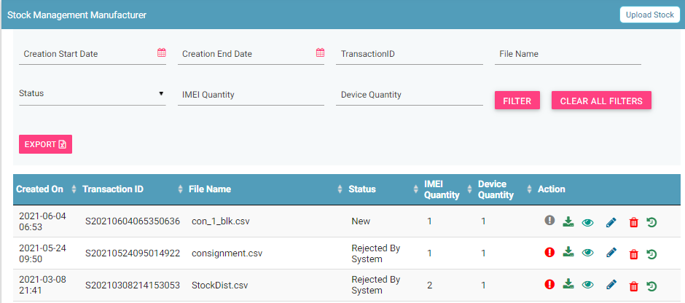

Figure 21: Stock Management

The **Edit Stock** page appears.

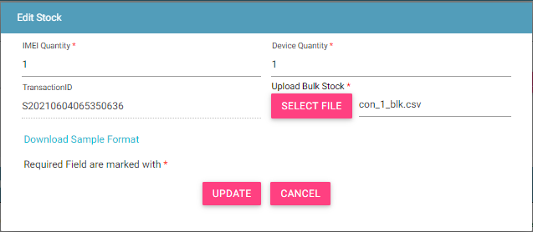

Figure 22: Edit Stock

1. Make the required changes.
2. Click **UPDATE**.

## Filter Stock

Manufacturers can view selective stock by defining specific values in the listed fields. For example, Manufacturers can view all the stock that is in the processing status or the stock that is pending for approval by the CEIR authority.

To view specific stock:



Figure 23: Stock Management

1. Enter the required value in one or more of the listed fields:

* **Start Date and End Date**: This refers to the period of uploading stock.
* **Transaction ID**: Each stock file is assigned a unique ID. Manufacturers can view specific stock by entering its stock transaction ID.
* **Stock Status**: This refers to the status of the stock such as New, Processing, Rejected by System, etc. Select the status of the stock to be displayed.

1. Click **FILTER**.

The stock that matches the specified values are shown in the dashboard.

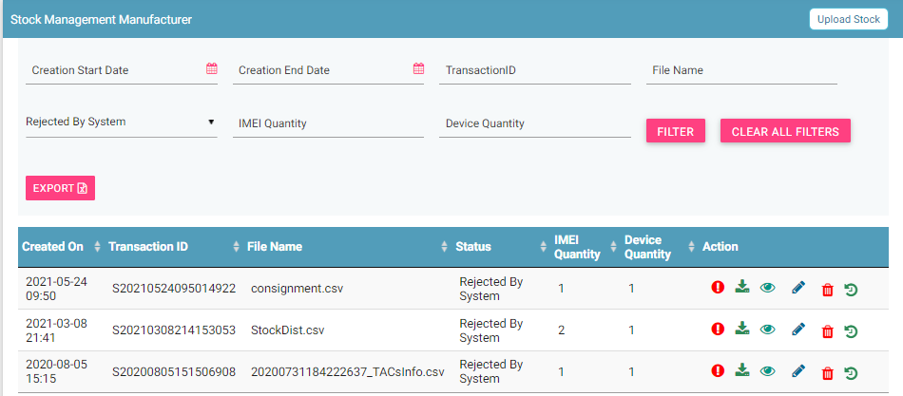

Figure 24: Stock Management

The user can clear all filters using the “**Clear All Filters**” button. This will reset all the filter values applied on the page and the data table will be refreshed.

## Sorting Stock

By default, all records displayed are sorted based on modified date. User can sort the records as per his convenience by clicking the arrow button on header in the table displayed.

On first click, the records are sorted in ascending order. When user clicks the arrow buttons again, records are sorted in descending order.

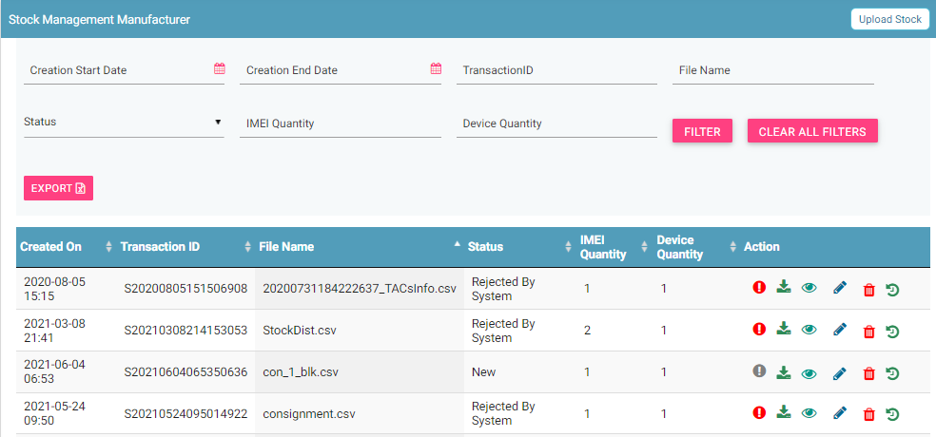

## Export Stock

Manufacturers can download all the uploaded stock data in a **.csv** file. This is done using an export utility.

To export the uploaded stock:

1. Click **Export** (seen on the top right corner of the **Stock Management** page).



Figure 25: Stock Management

The following page appears.

Figure 26: Open or Save Exported Stock File

1. Click **Open with** to view the file. The file opens as an Excel file.

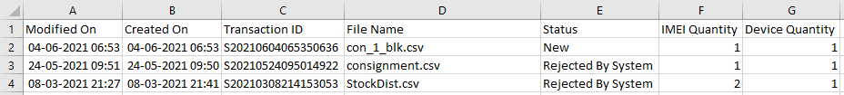

Figure 27: Exported Stock

Filtered stock can also be exported. To do this, filter stock based on specific filter values. Refer to *Filter Stock* for information and then export the filtered data.

## Grievance Management

Manufacturers can register complaints or grievances when there is a problem in the portal. For example, there could be situations when the registration feature is not working or there could be a problem in stock upload.

When a Manufacturer raises a grievance, the grievance goes through the following stages:

1. A notification is sent to the CEIR Admin. The notification appears on the CEIR Admin portal. A mail is also sent to the registered mail of the CEIR Admin.
2. The CEIR Admin responds to the grievance. A response notification is sent to on the Manufacturer portal, and the Manufacturer’s registered mail ID.
3. Steps 1 to 2 are repeated until the grievance is closed. The Admin closes the grievance.

There are situations when the grievance is automatically closed. A grievance is automatically closed when the status of the grievance changes to **Pending with User**, but there is no response from the Manufacturer for a specified period.

To raise a grievance

1. Select **Grievance Management** in the left panel.



Figure 28: Home Page

1. The **Grievance Management** page appears. Click **Report Grievance**.

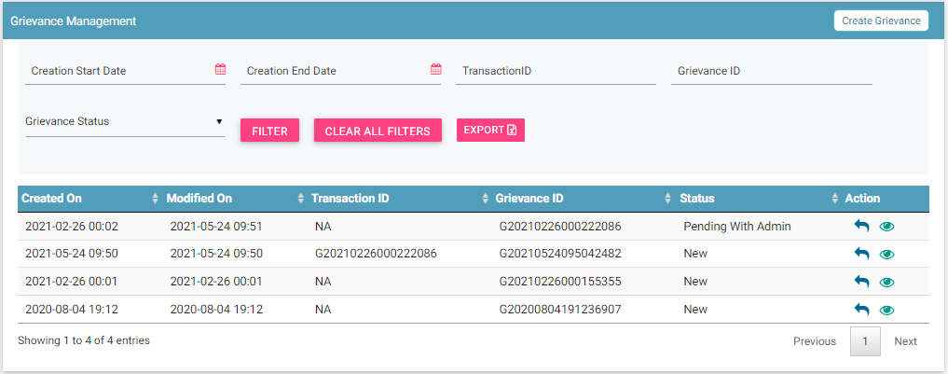

Figure 29: Grievance Management

The **Create Grievance** page appears.

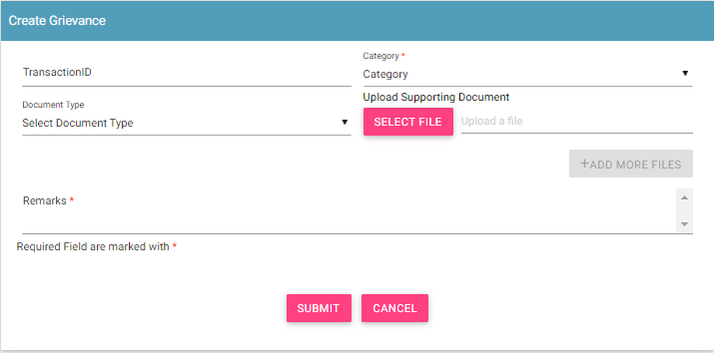

Figure 30: Create Grievance

1. Enter the following information:
   1. **Transaction ID**: Enter the transaction ID of the stock upload if the grievance is related to a stock upload.
   2. **\*Category**: Select the category of the grievance. The options are:

* Stock Related: Problem with uploading stock etc.
* Other: Problem with any other aspect of the application
* Registration Related: Problem with registering information in the application.
  1. **\*Remarks:** Enter information about the grievance raised. This helps the Admin to understand the problem in detail.
  2. **Document Type:** Select the type of identification or another document that is to be uploaded. The options are:
* Passport
* Visa
* NID (National ID)
* Photo
* Other
  1. **Upload Supporting Document:** Click **Select File** to upload the document selected in **Document Type**.
  2. To upload more documents,click **+Add More Files.**

This adds two more fields: **Document Type** and **Select File**.

1. Click **SUBMIT**.

A grievance ID is generated and assigned to the registered grievance. The registered grievance appears on top of the dashboard.

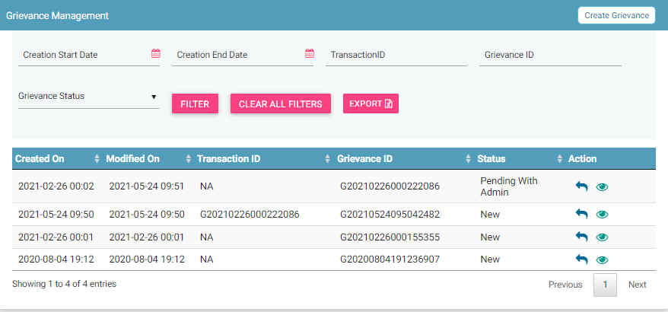

Figure 31: Grievance Management

For each grievance added, the following information is displayed on the page.

| **Column** | **Description** |
| --- | --- |
| Raised Date | Date of raising a grievance. |
| Modified On | The date when the grievance was modified. |
| Transaction ID | The transaction ID of stock for which a grievance was raised. |
| Grievance ID | This is the ID that is automatically assigned to the grievance. |
| Grievance Status | The uploaded grievance goes through different status modes.   * New: When a grievance is raised. * Pending with CEIR Authority: When a response is awaited from the CEIR Admin. * Pending with User: When a response is awaited from the Manufacturer. * Closed: When the CEIR Admin closes the grievance. |
| Action | This displays different actions that can be performed on a grievance.   * Reply : This is used to respond to the grievance. The response is given by the CEIR Admin or Manufacturer. The exchange of responses is done until the grievance is closed. * View A close up of a logo    Description automatically generated: This is used to view the grievance response history. The Manufacturer can see all the responses exchanged for any grievance. |

## Filter Grievances

The Manufacturer can view selective grievances depending on specific filter values. For example, the Manufacturer can view only those grievances that are pending with the CEIR Admin. Similarly, one can view only those grievances that are closed.

To filter grievances:



Figure 32: Filter Grievances

1. Specify the required value in one or more of the fields listed:

* **Start Date** and **End Date**: Period of raising grievances.
* **Transaction ID**: This is the transaction ID of the stock.
* **Grievance ID**: This is the ID assigned to the grievance.
* **Grievance Status**: The status can be:
  + New
  + Pending with CEIR Admin
  + Pending with User
  + Closed

1. Click **Filter**.

The filtered grievances are shown on the page.

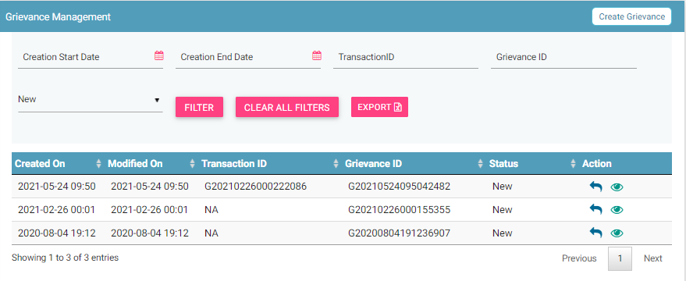

Figure 33: Filtered Grievances

The user can clear all filters using the “**Clear All Filters**” button. This will reset all the filter values applied on the page and the data table will be refreshed.

## Sorting Grievances

By default, all records displayed are sorted based on modified date. User can sort the records by clicking the arrow button on header in the table displayed.

On first click, the records are sorted in ascending order. When user clicks the arrow buttons again, records are sorted in descending order.

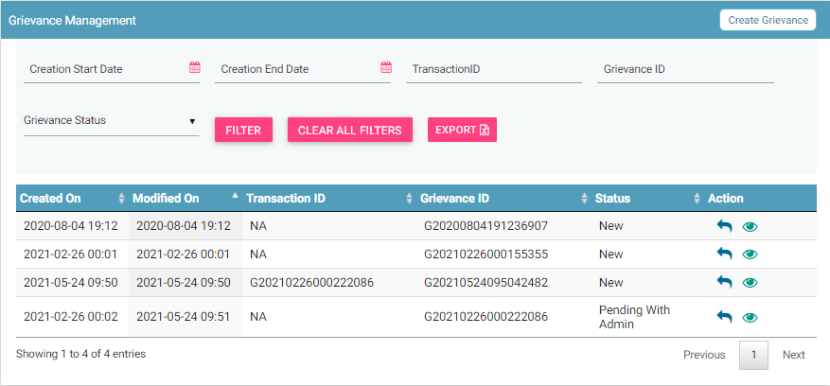

## Export Grievances

All the uploaded grievances can be downloaded in a **.csv** file. This is done using an export utility.

To export the grievances:

1. Click **Export** (seen on the top right corner of the **Grievance Management** page).

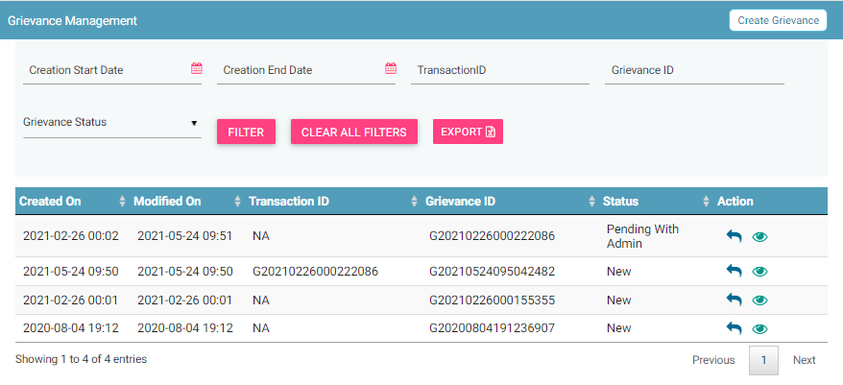

Figure 34: Grievance Management

The following page appears.

Figure 35: Open or Save Exported Grievance File

1. Click **Open with** to view the file.

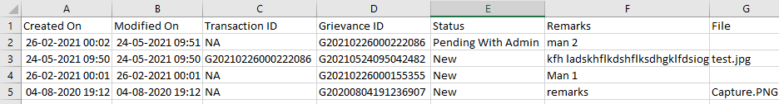

Figure 36: Exported Grievances

Instead of exporting all the grievances, Manufacturers can export filtered grievances. First, filter the grievance data based on specific filters (refer to *Filter Grievances*) and then export the filtered grievances using the export utility.